Gulfam Ali - Expert Proposals

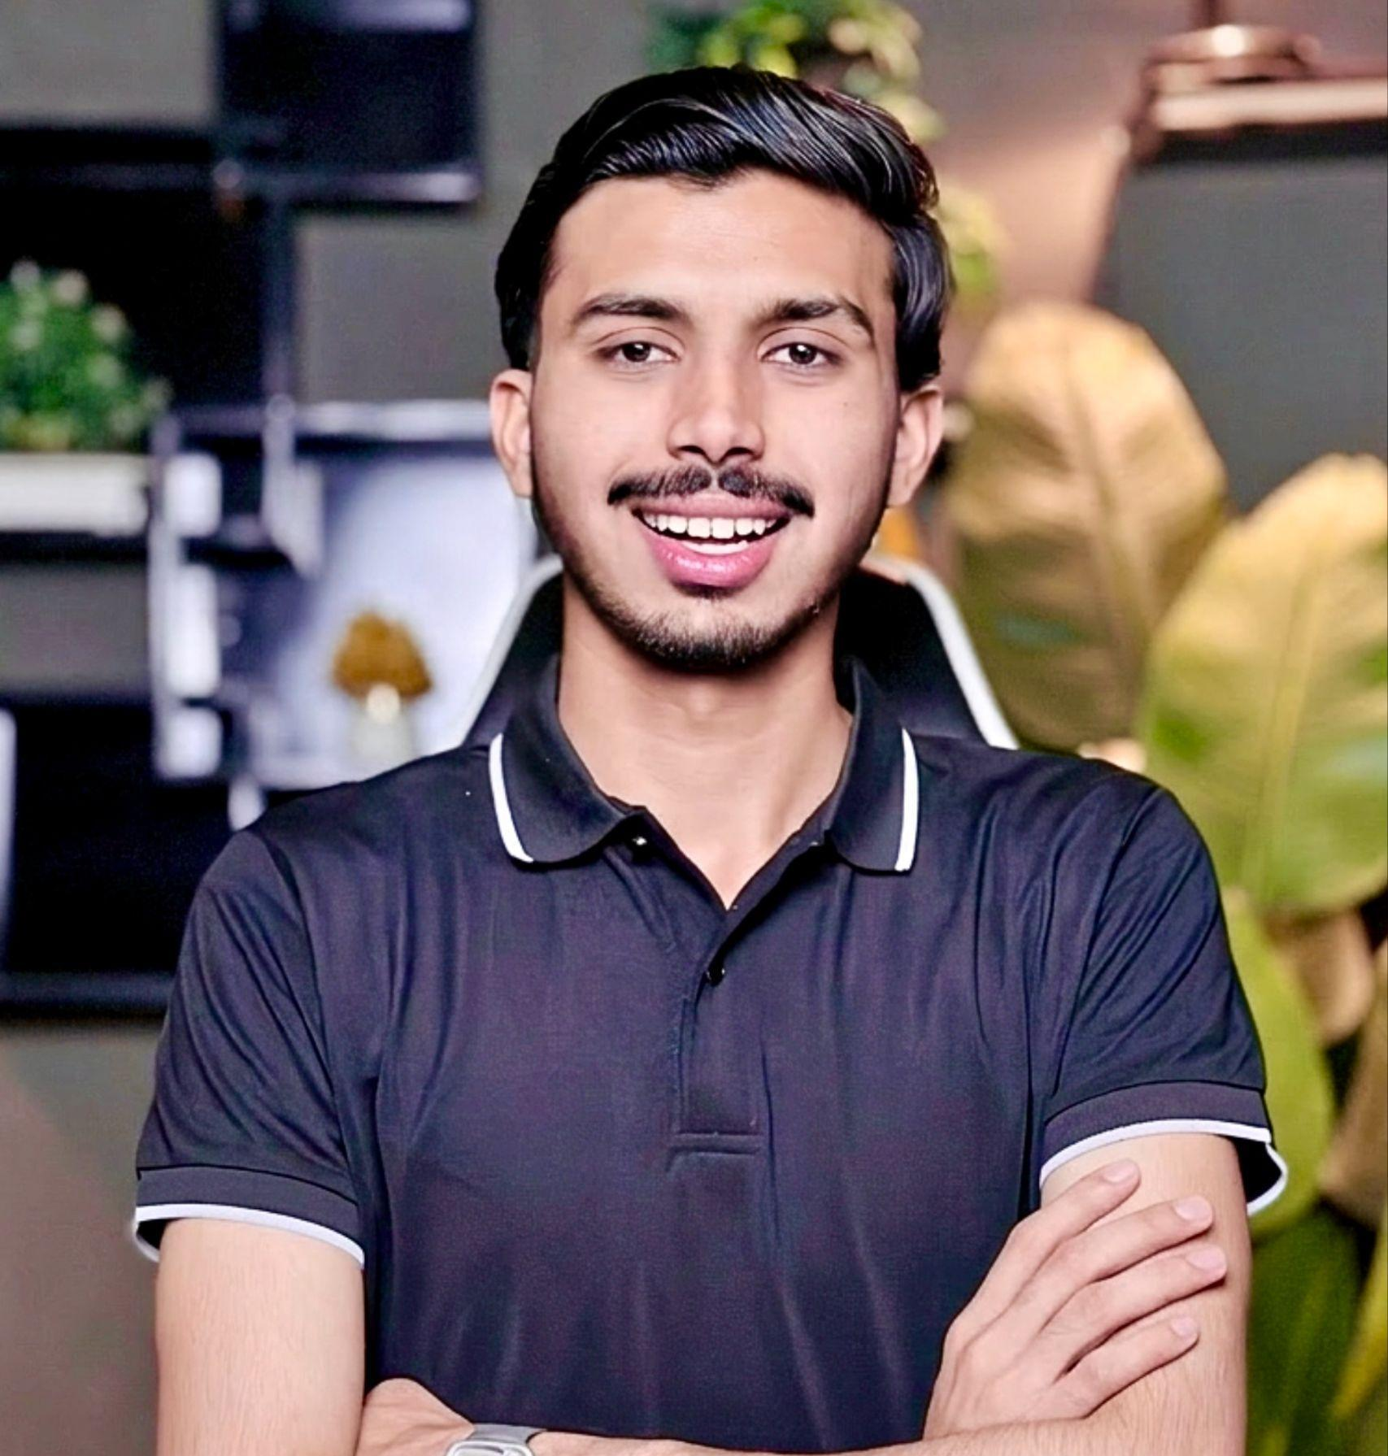

Linkedin Version
Hi Jam, thank you for connecting!
I noticed you manage content at Carnival Cruise Line. I help businesses like yours drive more organic traffic through SEO optimized articles that rank on Google and AI search engines.
I would love to support your content team with high quality articles. I can share samples anytime if you are interested.
Would you be open to a quick chat?
[Your Name]
Email Version:
Hi Jam,
Thank you for connecting on LinkedIn!
I noticed you manage content at Carnival Cruise Line and I believe I can add real value to your content strategy.
I am an SEO Content Writer specializing in high quality articles that rank on Google and AI search engines like ChatGPT and Gemini. My goal is simple — help businesses like yours get more organic traffic through content that actually performs.
Here is what I can offer:
- SEO optimized blog posts and articles
- Content optimized for Google and AI search engines
- Fast turnaround and professional delivery
- Consistent quality with every piece
I would love to share some writing samples so you can see my work firsthand.
Would you be open to a quick call or email conversation to explore if there is a fit?
Looking forward to hearing from you!
Best regards,
[Your Name]
[Your Contact]

SEO Content Writing Proposals (10 Niches

Business
Hi,
I noticed your business is growing, but your content isn’t fully leveraging SEO to bring consistent traffic and leads.
I help businesses turn blogs into lead-generation assets by targeting buyer-intent keywords and structuring content that ranks and converts.
What I offer:
• SEO-driven blog posts targeting decision-stage keywords
• Content aligned with your services and sales funnel
• Authority-building articles to increase trust
I can also audit one of your existing pages and show quick wins.
Best regards

Finance
Hi,
Finance content needs accuracy, trust, and SEO precision.
I specialize in:
• High CPC keyword targeting (loans, credit cards, investing)
• Clear and engaging financial explanations
• Content that builds topical authority
I can help you rank while maintaining credibility.
Best regards

Tech
Hi,
Tech audiences need clarity, depth, and up-to-date insights.
I create:
• SEO-optimized tech blogs (AI, SaaS, tools)
• Comparison and review content that converts
• Guides that rank and retain readers
Let’s turn your content into organic traffic.
Best regards

Health
Hi,
Health content requires trust, clarity, and SEO compliance.
I deliver:
• Well-researched, accurate content
• SEO structure aligned with Google guidelines
• Reader-friendly health guides
Let’s build authority in your niche.
Best regards

Fitness
Hi,
Fitness content is competitive—but the right strategy wins.
I write:
• Workout guides targeting search intent
• Diet and fitness blogs that engage
• SEO content that drives organic traffic
Let’s grow your audience.
Best regards

Fashion
Hi,
Fashion content should inspire and rank.
I create:
• Trend-based SEO articles
• Style guides and product-focused blogs
• Content that attracts organic shoppers
Let’s turn traffic into customers.
Best regards

Beauty
Hi,
Beauty content works best when it blends SEO with storytelling.
I offer:
• Product-focused blogs
• Skincare and beauty guides
• High-converting SEO content
Let’s increase visibility and engagement.
Best regards

Crypto
Hi,
Crypto content needs clarity, accuracy, and SEO.
I write:
• Beginner to advanced crypto guides
• SEO content targeting trending keywords
• Articles that simplify complex topics
Let’s grow your authority in crypto.
Best regards

Gaming
Hi,
Gaming audiences want engaging and updated content.
I deliver:
• Game guides and walkthroughs
• SEO blogs targeting gaming keywords
• Content that keeps users engaged
Let’s build traffic from gamers.
Best regards

Marketing
Hi,
Marketing content should educate and convert.
I create:
• SEO blogs on digital marketing strategies
• Case-study style content
• Content that positions you as an authority
Let’s scale your organic growth.
Best regards

—------------------------------------------------------------------------------------------------------------------

Gulfam Ali Email Marketing Templates



EMAIL OUTREACH TEMPLATE
Subject: Helping your business get more customers online
Hello,
I found your business while searching on Google Maps. Your services look great, but your social media presence is not active. Many customers check Facebook and Instagram before visiting a business.
I help local businesses attract more customers through professional posts, special offer promotions, and regular content that builds trust.
I can handle everything from design to posting so you don’t have to worry about marketing.
Can I send you a few ideas for your business?
Best regards,
[Your Name]

FOLLOW-UP MESSAGE (VERY IMPORTANT)
Hi again, just checking back. Many businesses I work with started getting more calls and walk-ins after we improved their social media content.
Let me know if you'd like to see some sample posts for your business.

BASIC PACKAGE: $150/month
Best for small shops
• 8 posts per month (2 per week)
• Post designs (offers, services, info posts)
• Captions writing
• Posting on 1 platform (Facebook or Instagram)
• Basic hashtag research

STANDARD PACKAGE: $300/month
Most recommended
• 12 posts per month (3 per week)
• Post designs + captions
• Posting on Facebook and Instagram
• 2 offer posts per month
• 1 article-style educational post per week
• Basic engagement (replying to comments)

PREMIUM PACKAGE: $500/month
For serious businesses
• 16 posts per month (4 per week)
• Post designs + captions
• FB + IG management
• Offer campaigns
• 2 article-style posts weekly
• Story posts (8 per month)
• Competitor research
• Monthly performance report

INSTAGRAM / FACEBOOK DM TEMPLATE
Hi 👋
I came across your business on Google Maps. Your services look really good, but I noticed your social media pages are not active.
I help local businesses grow by creating professional posts, offers, and useful content that brings in customers.
Would you like me to share a few ideas for your page?

Search like this:
Use the format:
Service + Location
- Plumber in New York
- Car repair shop in London
- Roofing company in Texas
- Lawyer in California
- Accountant in Dubai
- Restaurant in Manchester
- Beauty salon in Toronto
- Real estate agent in Florida
- Dental clinic in Birmingham
- Gym in Los Angeles
- Chiropractor in Sydney
- Pet grooming in Chicago
- Cleaning services in Houston
- Driving school in Melbourne
- Home renovation company in New Jersey
- Physiotherapy clinic in Toronto
- Catering service in Dallas
- Tattoo studio in Miami
- Photography studio in Vancouver
- HVAC company in Phoenix
- Pest control service in Atlanta
- Daycare center in Seattle
- Auto detailing in San Diego
- Spa and massage in Las Vegas
- Interior designer in San Francisco
Subscribe our YT channel and newsletter for more premium content like this.
Best regards
Gulfam Ali

