Gulfam Ali Email Marketing Templates

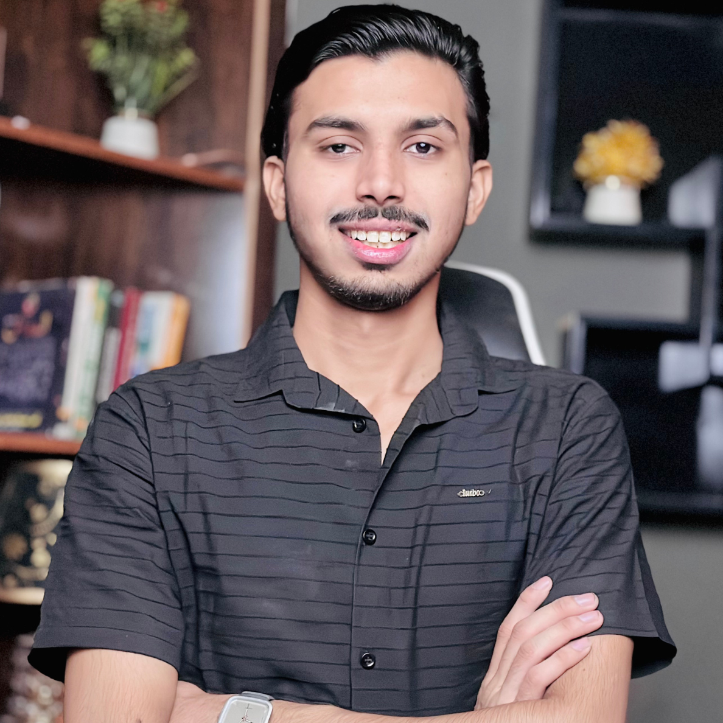

EMAIL OUTREACH TEMPLATE
Subject: Helping your business get more customers online
Hello,
I found your business while searching on Google Maps. Your services look great, but your social media presence is not active. Many customers check Facebook and Instagram before visiting a business.
I help local businesses attract more customers through professional posts, special offer promotions, and regular content that builds trust.
I can handle everything from design to posting so you don’t have to worry about marketing.
Can I send you a few ideas for your business?
Best regards,
[Your Name]

FOLLOW-UP MESSAGE (VERY IMPORTANT)
Hi again, just checking back. Many businesses I work with started getting more calls and walk-ins after we improved their social media content.
Let me know if you'd like to see some sample posts for your business.

BASIC PACKAGE: $150/month
Best for small shops
• 8 posts per month (2 per week)
• Post designs (offers, services, info posts)
• Captions writing
• Posting on 1 platform (Facebook or Instagram)
• Basic hashtag research

STANDARD PACKAGE: $300/month
Most recommended
• 12 posts per month (3 per week)
• Post designs + captions
• Posting on Facebook and Instagram
• 2 offer posts per month
• 1 article-style educational post per week
• Basic engagement (replying to comments)

PREMIUM PACKAGE: $500/month
For serious businesses
• 16 posts per month (4 per week)
• Post designs + captions
• FB + IG management
• Offer campaigns
• 2 article-style posts weekly
• Story posts (8 per month)
• Competitor research
• Monthly performance report

INSTAGRAM / FACEBOOK DM TEMPLATE
Hi 👋
I came across your business on Google Maps. Your services look really good, but I noticed your social media pages are not active.
I help local businesses grow by creating professional posts, offers, and useful content that brings in customers.
Would you like me to share a few ideas for your page?

Search like this:
Use the format:
Service + Location
- Plumber in New York
- Car repair shop in London
- Roofing company in Texas
- Lawyer in California
- Accountant in Dubai
- Restaurant in Manchester
- Beauty salon in Toronto
- Real estate agent in Florida
- Dental clinic in Birmingham
- Gym in Los Angeles
- Chiropractor in Sydney
- Pet grooming in Chicago
- Cleaning services in Houston
- Driving school in Melbourne
- Home renovation company in New Jersey
- Physiotherapy clinic in Toronto
- Catering service in Dallas
- Tattoo studio in Miami
- Photography studio in Vancouver
- HVAC company in Phoenix
- Pest control service in Atlanta
- Daycare center in Seattle
- Auto detailing in San Diego
- Spa and massage in Las Vegas
- Interior designer in San Francisco
Subscribe our YT channel and newsletter for more premium content like this.
Best regards
Gulfam Ali

